**Inventory Management System Project**

**Database Management System**

***Overview***

Project is related to Inventory Management System

* The project maintains three levels of users:-
  + Billing Counter Level
  + Manager Level
  + Owner Level
* Main facilities available in this project are:-
  + We can forecast the sales by analyzing the previous sales statistics.
  + We can get an idea that when we need to order new inventory.
  + We can reduce the chances of any kind of frauds done by the staff members in the inventory.
  + Customer details can be added.
  + Invoice generation.
  + We can keep a track of transactions received through different payment methods.

## INTRODUCTION-:

An inventory management system is the combination of technology (hardware and software) and processes and procedures that oversee the monitoring and maintenance of stocked products, whether those products are company assets, raw materials and supplies, or finished products ready to be sent to vendors or end consumers.

This system can widely be used by normal shops, departmental stores or MNCs for keeping a proper track of the stock. It also consists of information like manager details, customer details etc.

With the help of this system we can fix a minimum quantity of any inventory below which we need to place an order for that inventory. This will help us in good sales results and never the out of stock stage for any inventory.

## SCOPE:

* This will help us in maintain the exact count of any product.
* Can help us to set minimum quantity of any product below which we can order the product from manufacturer.
* Can reduce duplicate entries

## WORKING:

This application will have different front ends for different kinds of users. The person who is sitting on the billing counter will have access to only modify the quantity of any product i.e. he/she can either generate an invoice for any sold product or can generate a return note for any returns from any customer. The manager will have

the access to modify the rates if there exist any dynamic price inventory. The owner of the firm will have the access to generate the final report which will be consisting of sales done on any particular day, the total sales on any particular counter or by any salesperson.

## Purpose:

INVENTORY MANAGEMENT must tie together the following objectives

,to ensure that there is continuity between functions :

* Company’s Strategic Goals
* Sales Forecasting
* Sales & Operations Planning
* Production & Materials Requirement Planning.

*Inventory Management* must be designed to meet the dictates of market place and support the company’s Strategic Plan . The many changes in the market demand , new opportunities due to worldwide marketing , global sourcing of materials and new manufacturing technology means many companies need to change their Inventory Management approach and change the process for Inventory Control .

*Inventory Management* system provides information to efficiently manage the flow of materials , effectively utilize people and equipment , coordinate internal activities and communicate with customers . Inventory Management does not make decisions or manage operations, they provide the information to managers who make more accurate and timely decisions to manage their operations.

INVENTORY is defined as the blocked Working Capital of an organization in the form of materials . As this is the blocked Working Capital of organization, ideally it should be zero. But we are maintaining Inventory . This Inventory is maintained to take care of fluctuations in demand and lead time. In some cases it is maintained to take care of increasing price tendency of commodities or rebate in bulk buying.

## Goals of proposed system

1. **Planned approach towards working: -** The working in the organization will be well planned and organized. The data will be stored properly in data stores, which will help in retrieval of information as well as its storage.
2. **Accuracy: -** The level of accuracy in the proposed system will be higher. All operation would be done correctly and it ensures that whatever information is coming from the center is accurate.
3. **Reliability:** - The reliability of the proposed system will be high due to the above stated reasons. The reason for the increased reliability of the system is that now there would be proper storage of information.
4. **No Redundancy: -** In the proposed system utmost care would be that no information is repeated anywhere, in storage or otherwise. This would assure economic use of storage space and consistency in the data stored.
5. **Immediate retrieval of information: -** The main objective of proposed system is to provide for a quick and efficient retrieval of information.
6. **Immediate storage of information: -** In manual system there are many problems to store the largest amount of information.
7. **Easy to Operate: -** The system should be easy to operate and should be such that it can be developed within a short period of time and fit in the limited budget of the user.

## Background:

This application is nowadays a basic use of any company, firm, shop or departmental store because stock maintenance, stock forecasting are some things which are very essential these days for earning great profits.

In ancient times we need to maintain the complete inventory in paper pen method.

The ancient method is quite un-easy, uncomfortable and some times inaccurate. For overcoming this problem we came with a solution of inventory management system. From this system we can generate invoice for each and every purchase. In addition to this we can have the employee details, customer details in this system.

In short we can call this as all in one system..!!

**User Characteristics:**

Every user should be:

### ✓

Comfortable with computer.

* Should have knowledge of internet explorer.
* He must also have basic knowledge of English too.

# Technical Feasibility: Back End

In this project we’ve only implemented the back end of the system which is designed on “SQL Plus”

On this sequence query language we created 10 tables named:

* 1. Brands
  2. inv_user
  3. Categories
  4. Products
  5. Stores
  6. Providers
  7. Customer_cart
  8. Select_product
  9. Transaction 10.Invoice

# ADVANTAGES

1. **Inventory Balance.** Good inventory management helps you figure out exactly how much inventory you need. This makes it easier to prevent product shortages and keep just enough inventory on hand without having too much.
2. **Inventory Turnover.** Need to keep a high [inventory turnover ratio](https://www.fishbowlinventory.com/blog/2010/08/05/inventory-turnover-ratio/) to ensure your products aren’t spoiling, becoming obsolete or sucking up your working capital. Calculate how many times your inventory sells in a year and see where you can make better use of your resources.
3. **Repeat Customers.** Good inventory management leads to what every business owner wants – repeat customers. You want your hard-earned customers to keep coming back to your business to meet their needs. One way to do this is to make sure you have what they’re looking for every time they come.
4. **Accurate Planning.** Using smart inventory management, you can stay ahead of the demand curve, keep the right amount of products on hand and plan ahead for seasonal changes. This goes back to keeping your customers happy all year long.
5. **Warehouse Organization.** If we know which products are your top sellers and what combinations of products your customers often order together, you can optimize your warehouse setup by putting those products close together and in easily accessible places. This speeds up the picking, packing and shipping processes.
6. **Employee Efficiency.** We can empower your employees to help you manage inventory. Training employees to use barcode scanners, [inventory](https://www.fishbowlinventory.com/learn-more/?utm_source=blog&utm_medium=inventory-system-software&utm_campaign=inv-blog-top-10-benefits-inventory-management) [management software](https://www.fishbowlinventory.com/learn-more/?utm_source=blog&utm_medium=inventory-system-software&utm_campaign=inv-blog-top-10-benefits-inventory-management) and other tools helps them make better use of their time, and it helps your business make better use of its resources, both human and technological.
7. **Inventory Orders.** If you’ve done a good job keeping track of how much inventory you have on hand, you can make smarter decisions about when and what to order. Inventory management software lets you speed up the ordering process. You can simply scan a product barcode and type in some information to place an order and generate an invoice.
8. **Inventory Tracking.** If you have multiple locations, then inventory management becomes even more important because you need to coordinate your supplies at each location depending on differences in demand and other factors.
9. **Time Saving.** Inventory management is a great time-saving tool. By keeping track of all the products you have on hand and on order, you can save yourself the hassle of doing inventory recounts to make sure your records are accurate. This once again requires inventory management software.
10. **Cost Cutting.** When your inventory is humming along efficiently through your facilities, you can bet you’ll save a lot of money. Inventory management helps you avoid wasting money on slow-moving products so you can put it to better use in other areas of your business.

***Summary***

In this project we developed a complete back end software in which we can update the stock, modify stock, we can forecast the stock, generate invoice.

From this application we can get an update that if a particular inventory or stock is less than the some pre-fixed quantity then it’ll be easy for the manager/owner to reorder the product from supplier to overcome the “Out of Stock” stage.

In addition to this it can also help us to manage the warehouses, add warehouses which can be proved as very useful feature.

We can have complete customer details which can help us to retrieve the order details of regular customers.

From this program we can also keep a track of transactions performed by different customers/clients. We can also get an idea that how much fund we received from different payment methodologies.

***This application will keep a high*** [***inventory turnover***](https://www.fishbowlinventory.com/blog/2010/08/05/inventory-turnover-ratio/)[***ratio***](https://www.fishbowlinventory.com/blog/2010/08/05/inventory-turnover-ratio/) ***to ensure our products aren’t spoiling, becoming obsolete for our working capital. It’ll help us to calculate how many times inventory sells in a year and see where we can make better use of our resources.***

# ER DIAGRAM:

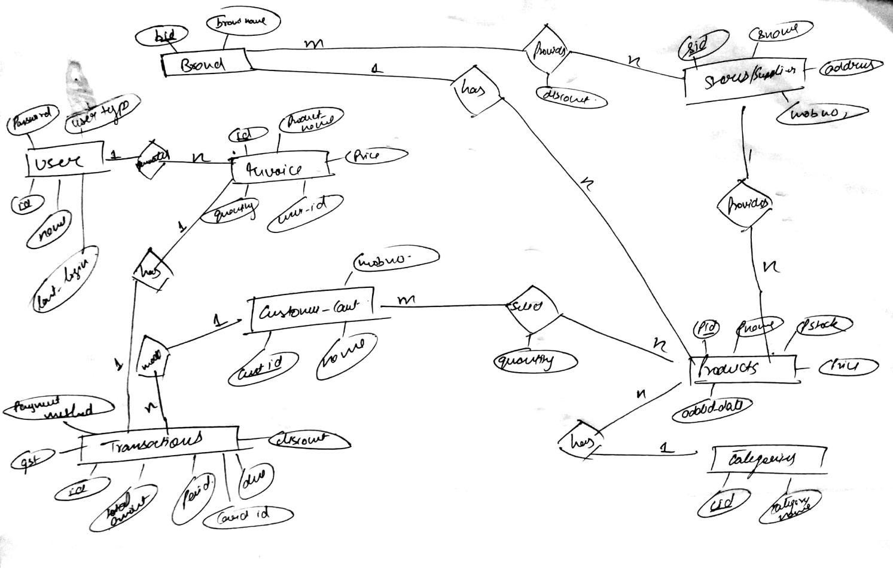

**RELATIONAL SCHEMA:**

